Name:

La Tomatina

Spain’s Largest Food Fight

Date:



Directions: Read each article about La Tomatina and answer the questions that follow.

**Part I. La Tomatina Is...**

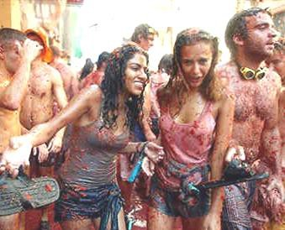

**La Tomatina** is a food fight festival held on the last Wednesday of August each year in the town of Buñol, just west of the city of Valencia in Spain. Thousands upon thousands of people make their way from all corners of the world to fight in

this **'World's Biggest Food Fight'** where more than one hundred metric tons of over-ripe tomatoes are thrown in the streets.

The week-long festival features **music**, **parades**, **dancing**,

and **fireworks**. On the night before the tomato fight, participants of the festival compete in a paella cooking contest.

Prior to 2013, anywhere from 40,000 to 50,000 (reported to be 50,000 in 2012) people crammed

into this huge **tomato fight**, greatly expanding Buñol's normal 9,000 person population. Since the 2013 event, official ticketing was put into place limiting the number of participants to just 20,000 lucky people.

There is limited accommodation for people who come to La Tomatina, so many people take the

easier option of staying in nearby **Valencia,** just 38km to Buñol by bus or train. In preparation for the dirty mess that will ensue, shopkeepers use huge plastic covers on their storefronts in order to protect them from the carnage.

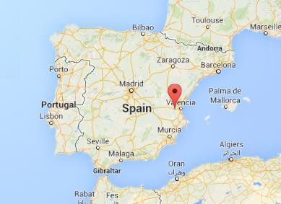

Buñol

**Part I Questions:**

1. What do partygoers do during the Tomatina?

2. In what city and country does *La Tomatina* take place?

3. *La Tomatina* is held on the last of the month of each year.

4. Besides a giant food fight, the festival of also features *(name three events)*

.

5. In 2012, the event reached people.

6. The event is now a ticketed event, with a maximum allowed amount of

people.

7. Many participants stay in the nearby city of _.

**Part II: What Happens at La Tomatina...**

At around 11 am, the first event of the Tomatina begins. Many trucks haul the bounty of tomatoes into the center of the town, Plaza del Pueblo. The tomatoes come from *Extremadura*, where they are less expensive.

Technically the festival does not begin until one brave soul has climbed to the top of a two-story high, greased-up wooden pole and reached the coveted ham at the top. In practice this process takes a long time and the festival starts despite no one reaching the meaty prize. The signal for the beginning of the fight is firing of water cannons, and the chaos begins. Once it begins, the battle is generally every man for himself.

Those who partake in this event are strongly encouraged to wear protective safety goggles and gloves. Although it is forbidden to tear someone else's clothing, the crowd tends to ignore this and will rip the shirt of any clothed person.

After exactly one hour, the fighting ends when the water cannons are fired once more to signal the end. At this point, no more tomatoes can be thrown. The cleaning process involves the use of fire trucks

to spray down the streets. Some people find water at the Buñol River to wash themselves, although some

kind residents will hose passers-by down. Once the tomato pulp is flushed, the ground is clean due to the acidity of the tomato.

**The Rules of La Tomatina**



• Do not bring bottles or hard objects as they can cause accidents and hurt other participants.

• Do not rip other people’s T-shirts.

• You must squash the tomatoes before throwing them, as this reduces the impact.

• As soon as you hear the second shot, you must stop throwing tomatoes.

**Useful Advice**

• Wear closed shoes that you don’t mind throwing away afterwards. If you wear flip-flops, you may get hurt, or you could lose them easily during the battle.

• Wear old clothes, or clothes that you aren’t planning to wear again. They will most likely end

up damaged from being ripped or incredibly dirty.

• You may find goggles useful. However, it is safer if you just ensure that you always have something clean to wipe your eyes with. The best thing is if you tuck your T-Shirt into your shorts to keep the bottom part of your T-shirt clean and dry.

• If you are planning to take pictures, bring a waterproof camera!

• Do not miss the Palojabón – a soap-covered pole with a Spanish ham at the top: whoever can climb the pole and get the ham can keep it!

**Part II. Questions:**

8. The centre of town where the battle takes place:

9. The tomatoes are shipped from the city of .

10. Why are the tomatoes brought from this location?

_.

11. Name four rules of La Tomatina:

a. b. c. d.

12. What rule is commonly ignored by participants?

13. The beginning and end of the festival are signaled by the firing of

_.

14. How long does the tomato fight last?

15. What is the Palojabón?

**Part III: How did La Tomatina Start...**

The Spanish *LOVE* to eat tomatoes and reportedly eat over 30 pounds per person annually! As with all Mediterranean cuisines, the tomato is an essential ingredient of Spanish cooking. The Spanish eat tomatoes every day and prepare them in a variety of ways, including fresh, crushed, stewed or simmered in a sauce. Tomato sauce is served on the side with fried eggs, chicken, meat and omelets at most Spanish dinner tables.

It's not too hard to understand that the very *loca* (crazy) *La Tomatina* festival started by accident. The tomato fight has been a strong tradition in Buñol since 1944 or 1945. According to all accounts, there was a parade and festival in Buñol on the last Wednesday of August of 1945 when a fight broke out between some young men. Taking advantage of a nearby fruit and vegetable vendor’s stall, they threw tomatoes at each other.

The following year the young people brought tomatoes with them to the parade and started a tomato fight again. Each year the fight continued until the early 1950’s when it was prohibited by order of the town council, but some townsfolk insisted on creating a fight and were thrown in jail. Protests ensued, including a “Tomato Funeral” and finally, in 1957 the town council allowed the fight to continue. The holiday was banned under Francisco Franco for having no religious significance, but returned in the 1970s after his demise. Since 1980 the city government has provided the tomatoes!

Article source: [*http://www.latomatinatours.com/*](http://www.latomatinatours.com/)

**Part III Questions:**

16. The tradition began when a tomato fight broke out during a _.

17. The Spanish reportedly eat of tomatoes per person, per year.

18. The tomatoes are now provided by the .

19. The holiday was banned by temporarily, but returned in the 1970s.

**La Tomatina**

**Crossword**

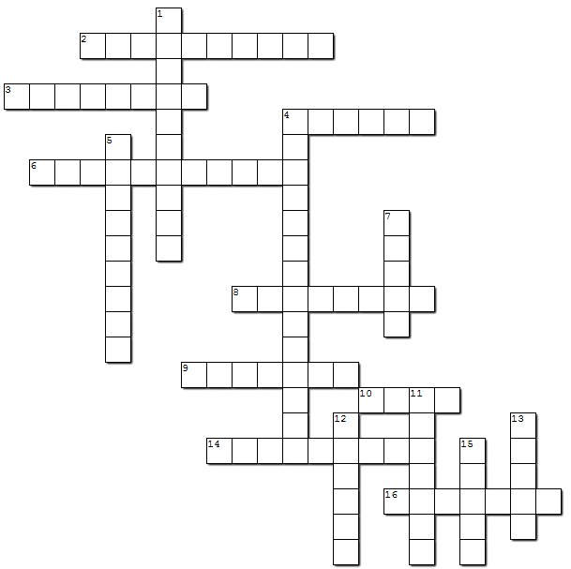

**Across**

• **2.** the name of this festival

• **3.** La Tomatina involves the throwing of

• **4.** La Tomatina began when a fight broke out during a .

• **6.** city that the tomatoes are brought from

• **8.** The event is held near this major city

• **9.** The event is no longer free, participants must buy _.

• **10.** crazy in Spanish

• **14.** a soap-covered pole with a ham at the top

• **16.** Remember to wear on your eyes.

**Down**

• **1.** the local provides the tomatoes

• **4.** the name of the town's centre

• **5.** The holiday was banned by Franco

• **7.** country this festival is located in

• **11.** water signal the beginning and end of the event.

• **12.** There is also a cooking contest

• **13.** people wash themselves at the Buñol

• **15.** This festival is a massive food .